**Architectural Design Record**

Documentation of important design decisions made during the course of the project.

**Monolith vs Microservices**

A monolith approach was chosen over a microservices approach. This was as the project is relatively small scale and had a limited and clearly defined scope. A microservices approach would be too complex for a project of this scale, and could potentially cause more issues (eg. with communication between services). A monolith was regarded as the simpler, safer choice for a project that does not necessarily need to scale (as it can be run on a local personal computer).

**Choice of dependency manager**

Conda and other package/dependency managers proved to be unreliable, as members had issues getting the project running using them. PDM proved to be more reliable and performant, which we thus used.

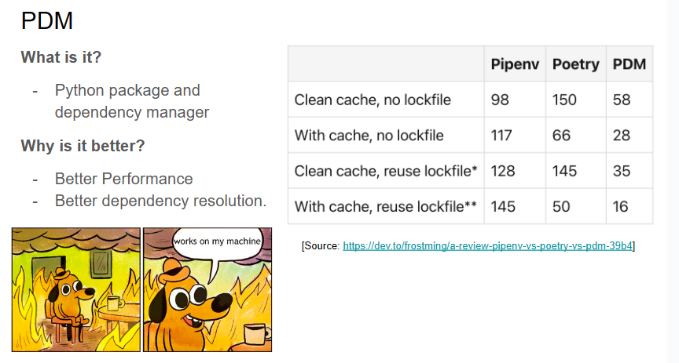

**Choice of Flask over JS**

While the project was initially supposed to be done in JavaScript, members’ inexperience with JS was a potentially large hurdle to overcome when combined with relative inexperience with front-end development and the limited time available. Flask was chosen due to members’ familiarity with python, the framework itself, and the following considerations:

